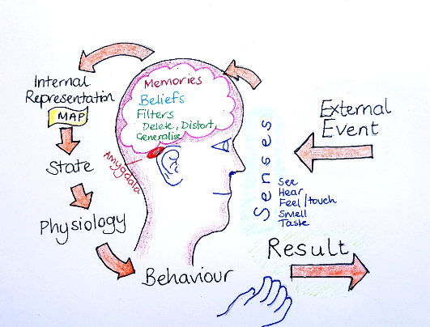

Here’s the picture of the 'communication model' Anna discussed. It explains how our thoughts and beliefs shape our experiences, and is a reminder to 'respond not react'.

Just a reminder of the mindfulness definition:
"Mindfulness is the awareness that arises through paying attention, on purpose in the present moment, without judgement." Jon Kabat-Zinn

